## QUESTION 1

The table below contains information about tweets over a given period of time. Calculate the 3-day rolling average of tweets published by each user for each date that a tweet was posted. Output the user id, tweet date, and rolling averages rounded to 2 decimal places.

Important Assumptions:

1. Rows in this table are consecutive and ordered by date.
2. Each row represents a different day
3. A day that does not correspond to a row in this table is not counted. The most recent day is the next row above the current row.

Note: Rolling average is a metric that helps us analyse data points by creating a series of averages based on different subsets of a dataset. It is also known as a moving average, running average, moving mean, or rolling mean.

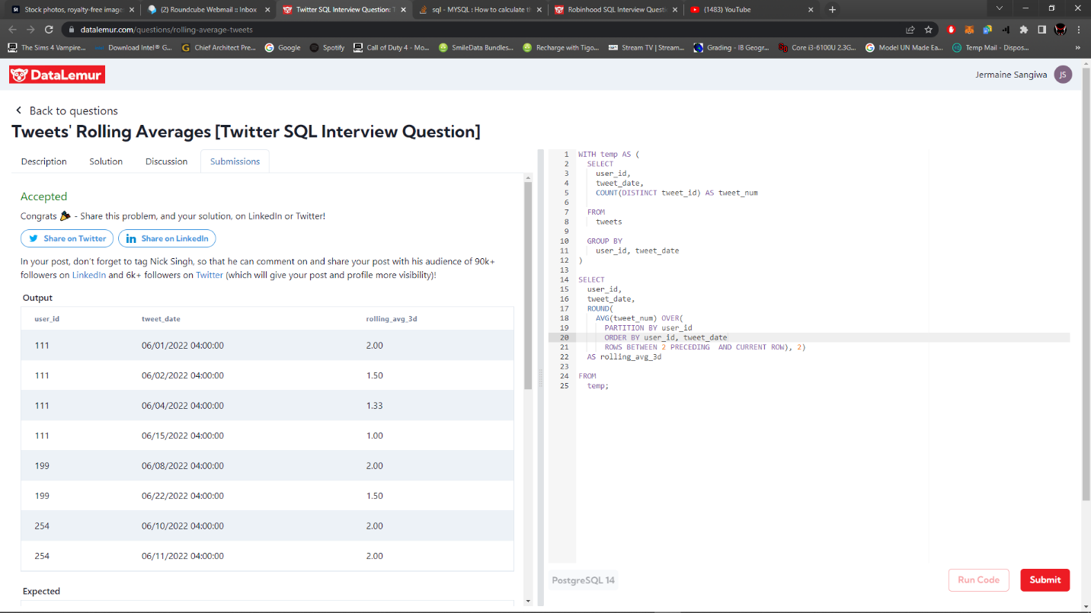

Solution to Question 1

## QUESTION 2

You are given the tables below containing information on Robinhood trades and users. Write a query to list the top three cities that have the most completed trade orders in descending order.

Output the city and number of orders.

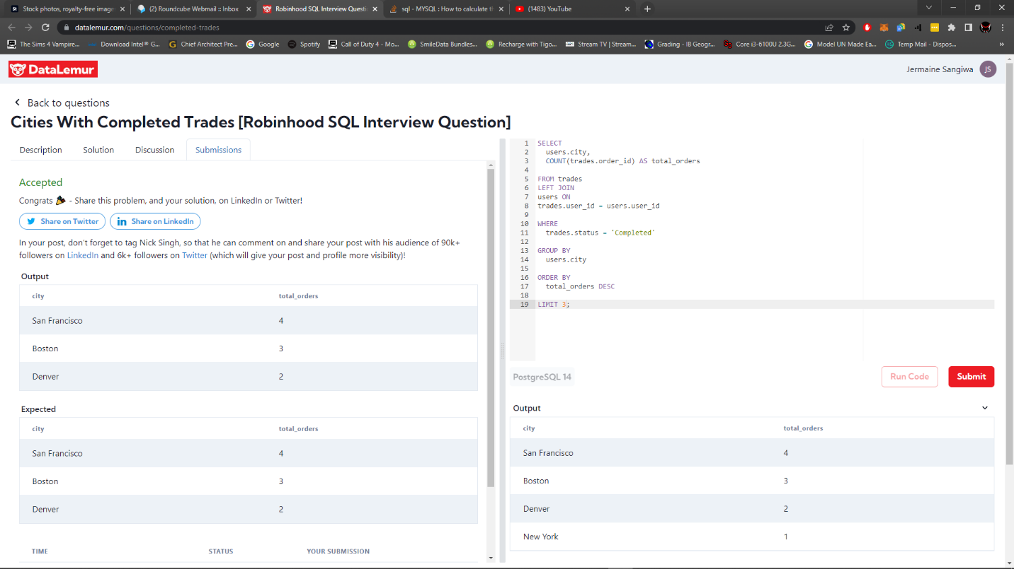

Solution to Question 2